AI Assignment-02

Jeetu Mehra
U24AI032

Question 1 : The following figure shows the start state and goal state for the 8-puzzle problem. Find the number of states explored before reaching the goal state using the BFS algorithm.
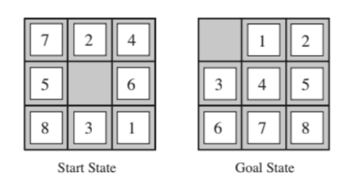
Code:
def get_neighbors(state):
neighbors = []
idx = state.index(0)
row, col = idx // 3, idx % 3
moves = [(-1, 0), (1, 0), (0, -1), (0, 1)]
for r_move, c_move in moves:
new_row, new_col = row + r_move, col + c_move
if 0 <= new_row < 3 and 0 <= new_col < 3:
new_idx = new_row * 3 + new_col
new_state = list(state)
new_state[idx], new_state[new_idx] = new_state[new_idx], new_state[idx]
neighbors.append(tuple(new_state))
return neighbors

def bfs_solver(start, goal):
queue = [(start, 0)]
visited = {start}
explored_count = 0
while queue:
current_state, depth = queue.pop(0)
explored_count += 1
if current_state == goal:
return explored_count, depth
for neighbor in get_neighbors(current_state):
if neighbor not in visited:
visited.add(neighbor)
queue.append((neighbor, depth + 1))
return -1, -1

start_state = (7, 2, 4, 5, 0, 6, 8, 3, 1)
goal_state = (0, 1, 2, 3, 4, 5, 6, 7, 8)

explored, cost = bfs_solver(start_state, goal_state)
print(f"BFS Explored States: {explored}")
print(f"BFS Cost: {cost}")

Output:
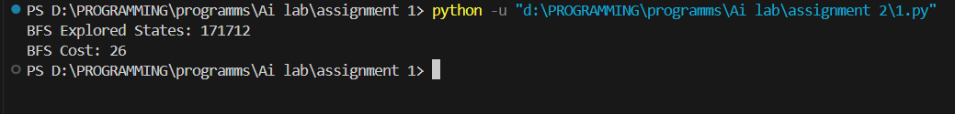

Question 2 : Find the number of states explored for the DFS algorithm. Give comparison of BFS
and DFS in terms of cost if the path cost for the state is given as depth of the search tree
at which the state is occurring.
Code:
def get_neighbors(state):
neighbors = []
idx = state.index(0)
row, col = idx // 3, idx % 3
moves = [(-1, 0), (1, 0), (0, -1), (0, 1)]
for r_move, c_move in moves:
new_row, new_col = row + r_move, col + c_move
if 0 <= new_row < 3 and 0 <= new_col < 3:
new_idx = new_row * 3 + new_col
new_state = list(state)
new_state[idx], new_state[new_idx] = new_state[new_idx], new_state[idx]
neighbors.append(tuple(new_state))
return neighbors

def dfs_solver(start, goal):
stack = [(start, 0)]
visited = {start}
explored_count = 0
while stack:
current_state, depth = stack.pop()
explored_count += 1
if current_state == goal:
return explored_count, depth
for neighbor in get_neighbors(current_state):
if neighbor not in visited:
visited.add(neighbor)
stack.append((neighbor, depth + 1))
return -1, -1

start_state = (7, 2, 4, 5, 0, 6, 8, 3, 1)
goal_state = (0, 1, 2, 3, 4, 5, 6, 7, 8)

explored, cost = dfs_solver(start_state, goal_state)
print(f"DFS Explored States: {explored}")
print(f"DFS Cost: {cost}")

Output:
